[Travel Management System]

PROJECT Report

***Submitted by***

**ADITHYA REDDY.P (RA1911028010095)**

**CHITTOJI RAGHAVA (RA1911028010105)**

**DEVATHA SAI TEJA (RA1911028010104)**

***in partial fulfillment for the award of the degree of***

# B.TECH

***in***

COMPUTER SCIENCE and ENGINEERING

IN

CLOUD COMPUTING

# SRM INSTITUTE OF SCIENCE AND TECHNOLOGY

KATTANKULATHUR

[April, 2022]

ABSTRACT

This Travel Management System Projects facilitates the agency to keep track of the travel trips database of the users like their personal details, trip dates, trip plans, and the cost of their travel, etc.

The aim of case study is to design and develop a database maintaining the records of different users, travel status and details of the trips.

This project is simple, user friendly and created with simple interface.

This project contains Introduction to the Travel Management system.

It is the computerized system of maintaining the database.

Then this project contains entity relationship model diagram based on Travel Management system and relation models.

This “Travel Management System” project is developed using C++ command prompt as front end and MySql as backend.

This project uses phpmyadmin sql database for storing the database and C++ to provide an simple interface for agency to add user, find user, edit user, delete user, etc functionalities.

TABLE OF CONTENT

|  |  |  |
| --- | --- | --- |
| **CHAPTER NO** | **TITLE** | **PAGE NO** |
| **1** | **ABSTRACT** | 2 |
| **2** | **LIST OF FIGURES** | 4 |
| 3 | **LIST OF ABBREVATIONS** | 5 |
| **4** | **INTRODUCTION** | 6 |
| **5** | **LIST OF Relationships** | 7 |
| **6** | **Entity Relationship Diagram** | 8 |
| **7** | **Normalized Database Table** | 9 |
| **8** | **SQL Queries with results** | 10-17 |
| **9** | **Conclusion and Future Work** | 18 |
| **10** | **References** | 18 |

# LIST OF FIGURES

|  |  |  |
| --- | --- | --- |
| **Figure No.** | **Title** | **Page No.** |
| 1 | LOGIN Entity | 6 |
| 2 | AGENCY Entity | 6 |
| 3 | TRAVELUSER Entity | 6 |
| 4 | TRAVELTRIP Entity | 6 |

# LIST OF ABBREVIATIONS

|  |  |
| --- | --- |
| **Abbreviations** | **Description** |
|  | Primary Key of an entity |
|  | Normal Attribute |
|  | Entity |
|  | Relationship type |
|  | Straight Relationship line |

# INTRODUCTION

# Database is a organized collection of data which is typically organized to model aspects of reality in a way that supports processes requiring information . DBMS makes it possible for end users to create, read, update, delete data in a database. This is a Travel management system in which the agency manages the database of students or users of their travel trips.

# It facilitates the agency to keep track of the travel trips database of the users like their personal details, trip dates, trip plans, and the cost of their travel, etc. Due to automation many loopholes that exist in the manual maintenance of the records can be removed. For future expansion the proposed system can be web enabled so that clients can make various enquiries about their travel history.

This project uses Codeblocks (C++ command prompt) as an user interface which is simple to understand and phpmy admin sql is connected to maintain the connection between the database and the command promt.

# List of Entities And Relationships :-

1. **LOGIN** – It contains the information about all the login details required for the user to login to travel agency. Relationship is every agency user has a login. It has a primary key login_username .

|  |
| --- |
| **LOGIN** |
| login_username |
| password |

1. **AGENCY** – This is the entity that stores the Login users for accessing the travelusers and traveltrip entities. Relationship many to one since one agency can have many users.

|  |
| --- |
| **AGENCY** |
| user_id |
| username |

1. **TravelUsers** – It has the attributes t_id, t_username, t_useraddress, t_userphone, t_useremail, t_usertripdate, t_usertripplan, trip_usertripcost. This entity keeps the details of personal details and trip details of the customers. Relationship is every traveluser can manage travel trips.

|  |
| --- |
| **Travelusers** |
| t_id |
| t_username |
| t_useraddress |
| t_userphone |
| t_useremail |
| t_usertripdate |
| t_usertripplan |
| trip_usertripcost. |

4)**TRAVELTRIP** – It has the attributes t_id, t_trip which keeps the details of the trip locations.

Travel trips can be viewed by every Agency user and can be managed by traveluser.

|  |
| --- |
| **TRAVELTRIP** |
| t_id |
| t_trip |

# Entity Relationship Diagram

The above mentioned individual entities when arranged sequentially in order of hierarchy, then we will obtain an ER Diagram.

Relationship between login and agency is one to many relationship.

Relationship between travelusers and traveltrip is many to many relationship.

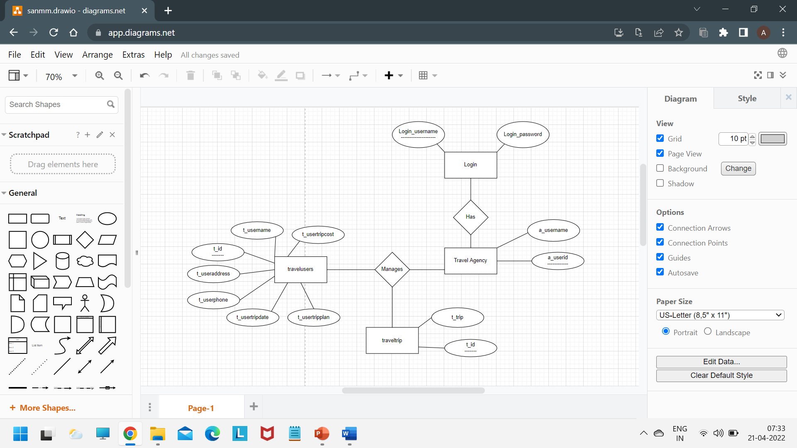

# Normalized Database Tables

When the above ER diagram is converted to relational model as we move from conceptual design to logical design we get 2 relations or tables. All these tables will be in 1NF as belong to RDBMS. In all these relations only the unique attribute reserves the ability to uniquely determine all the other prime as well as non-prime attributes.

1NF form of tables :-

1)Travelusers

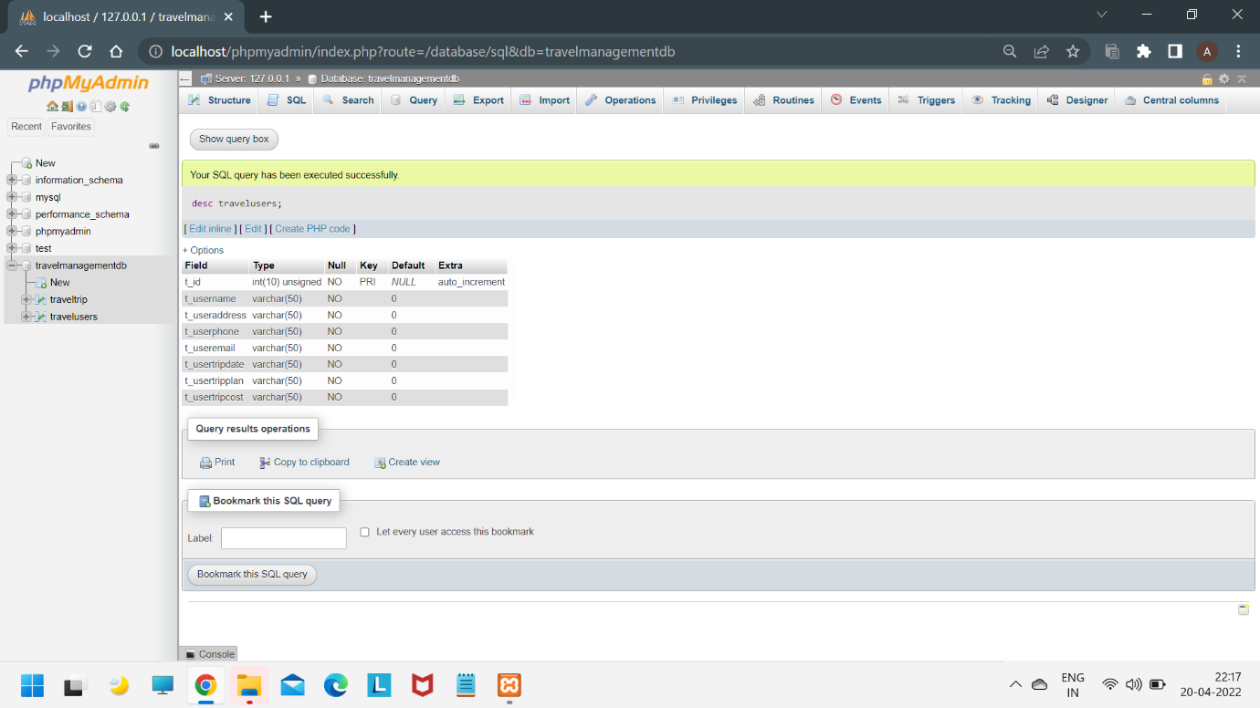

2)Traveltrip

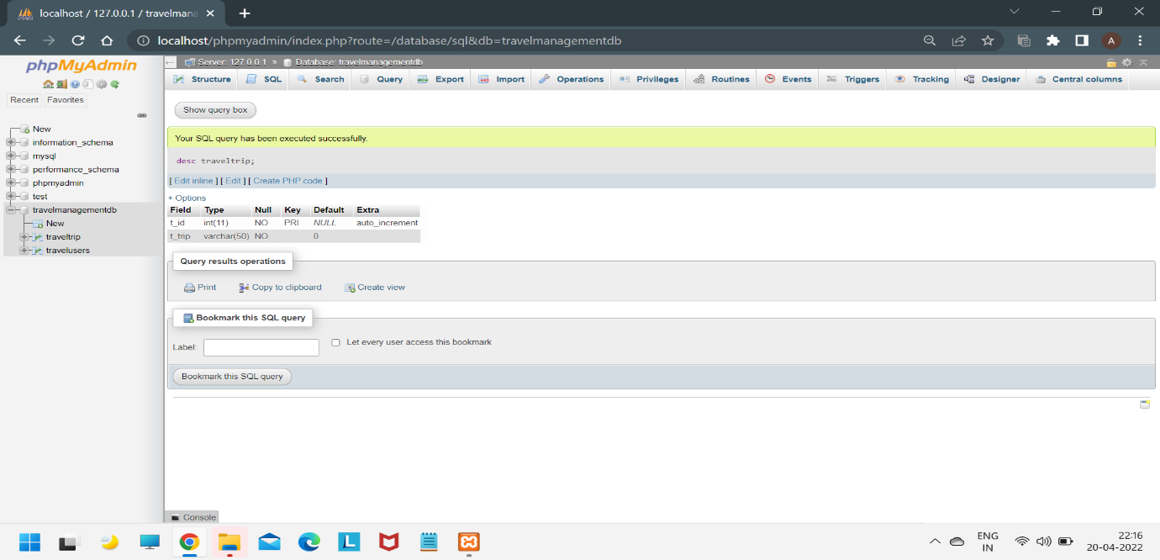

SQL QUERIES WITH RESULTS

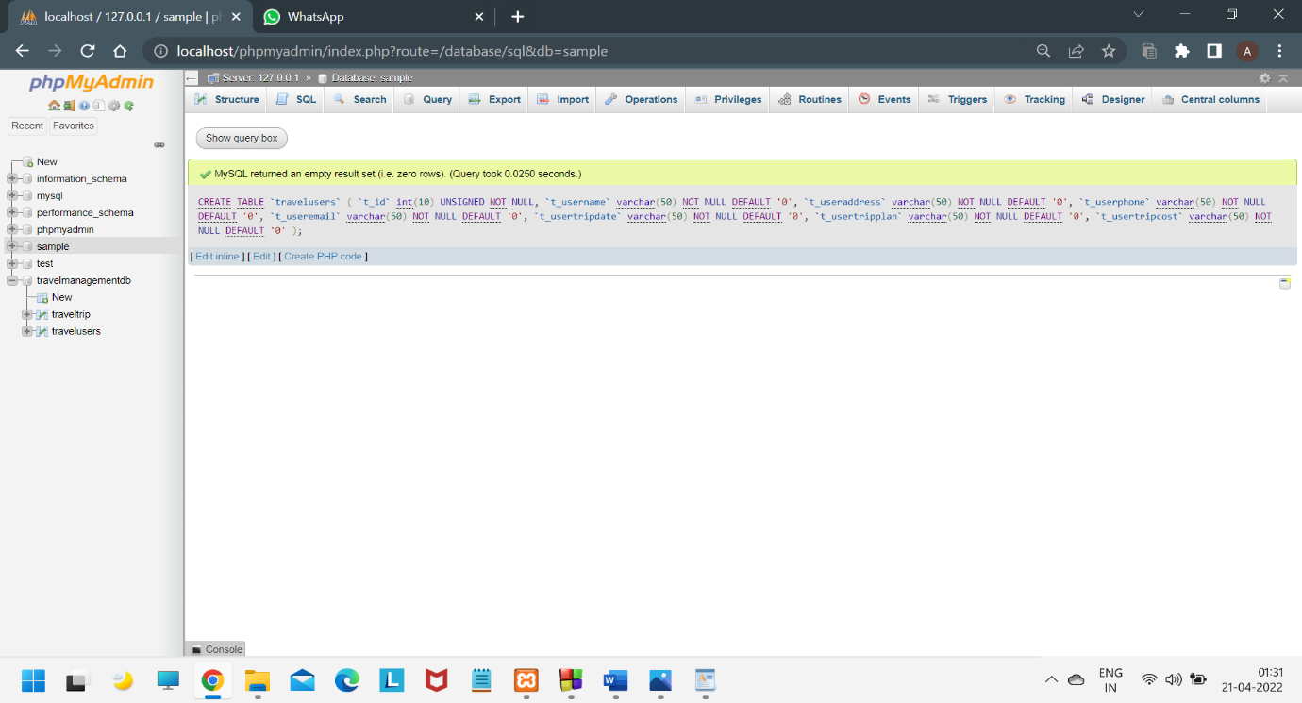

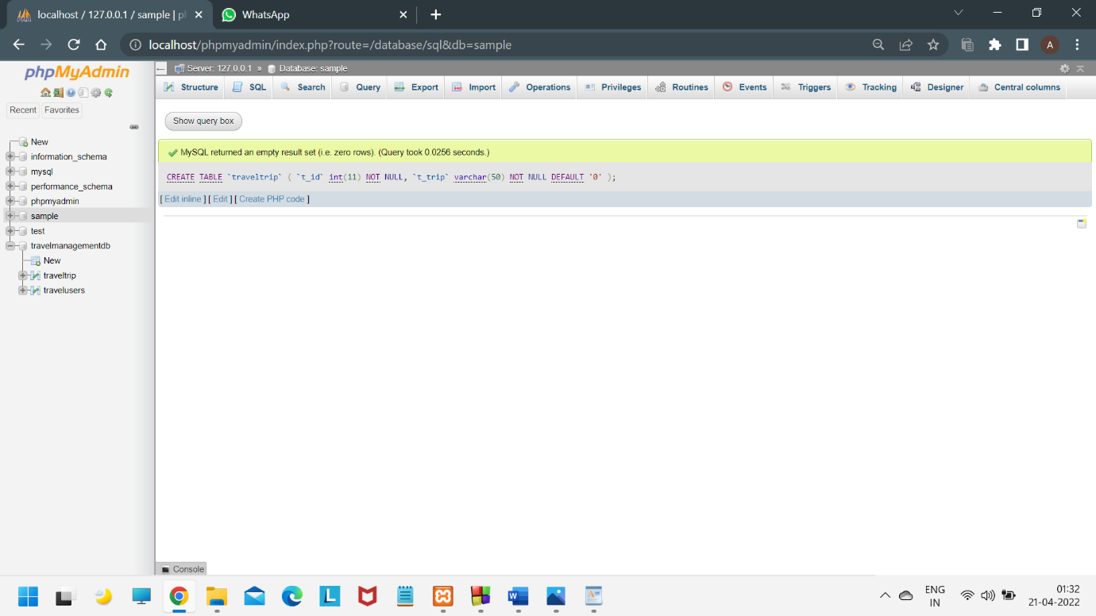

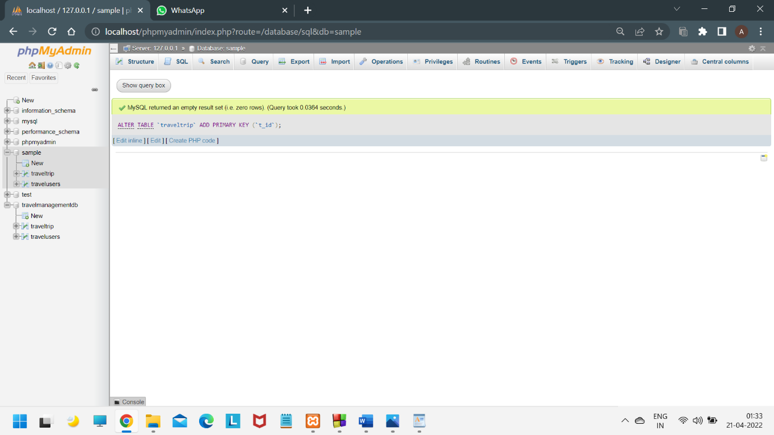

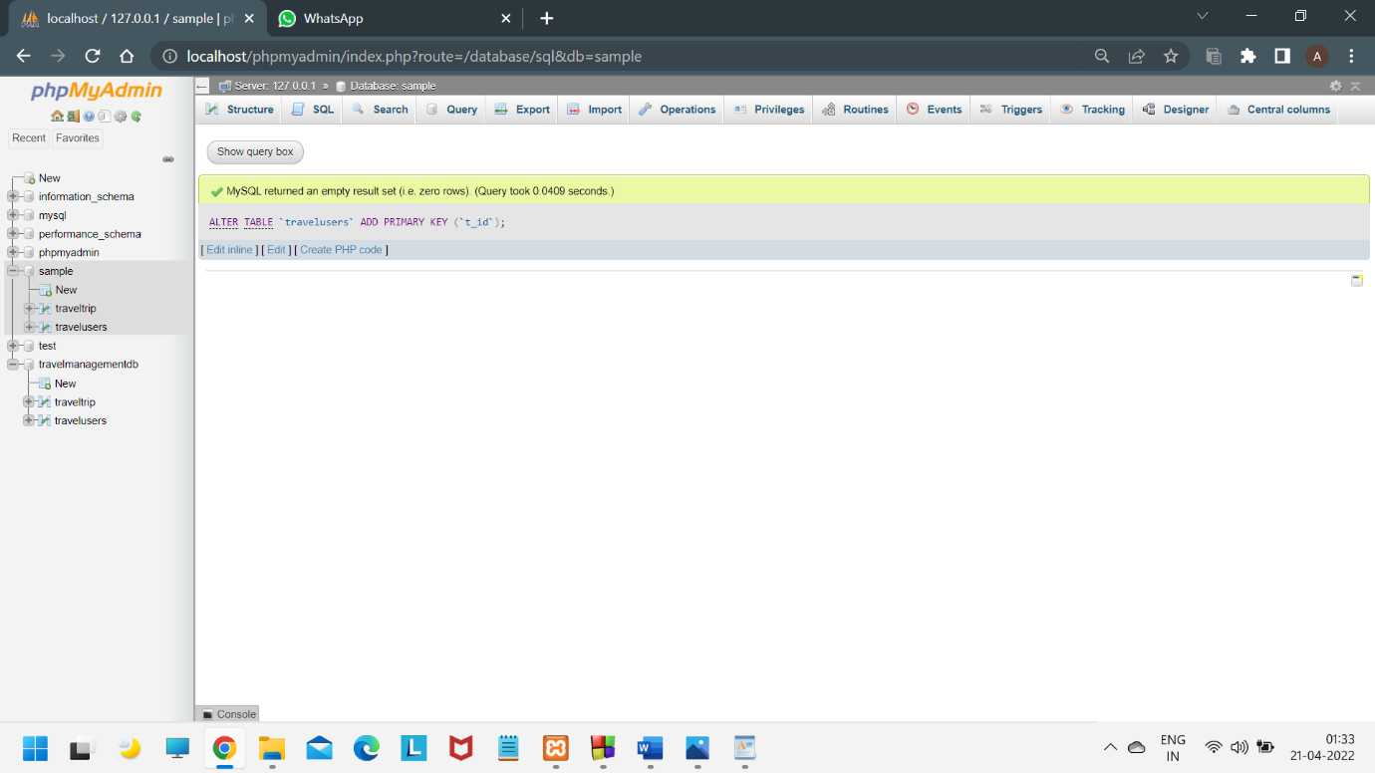

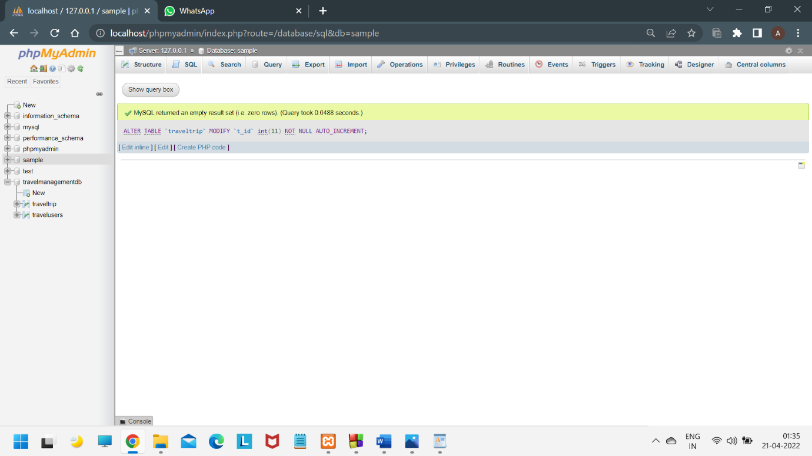

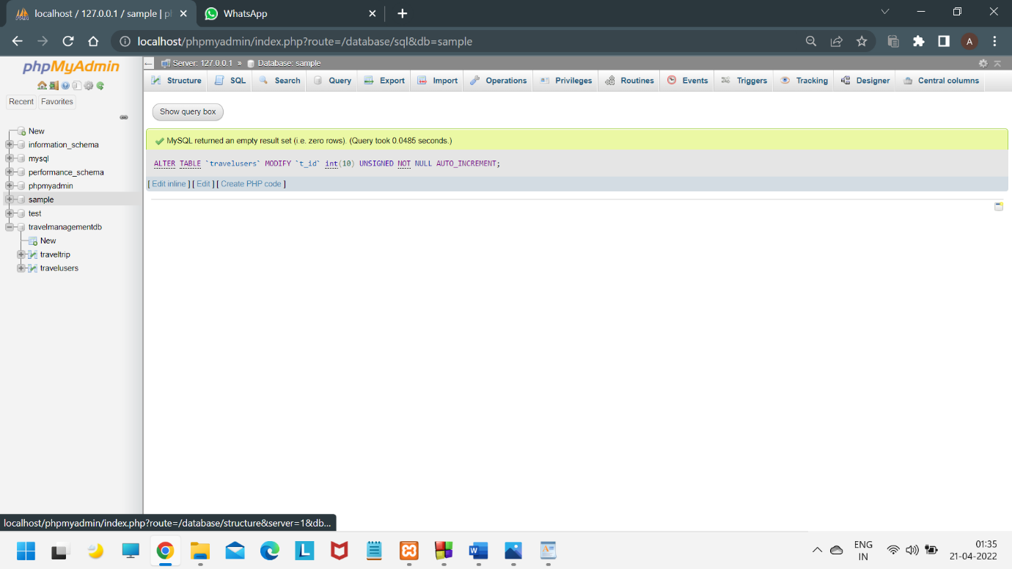

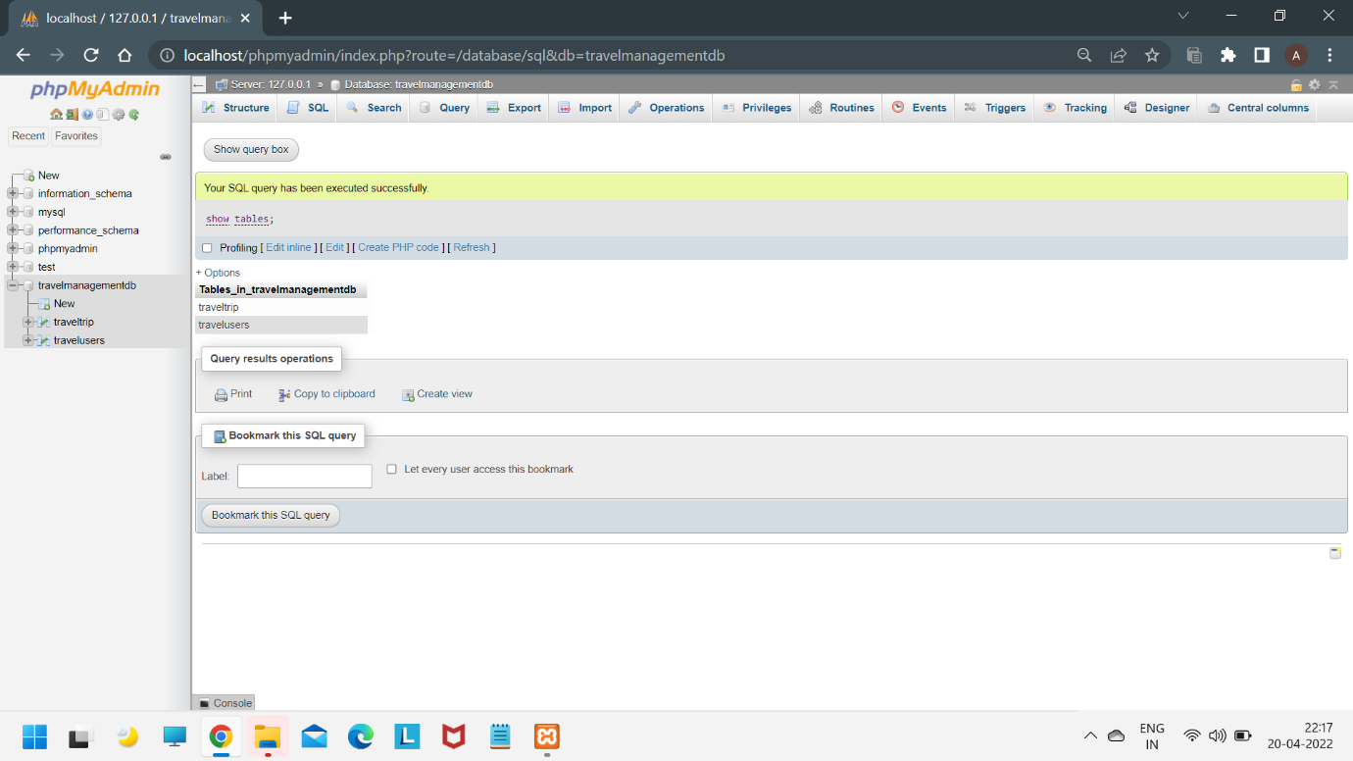

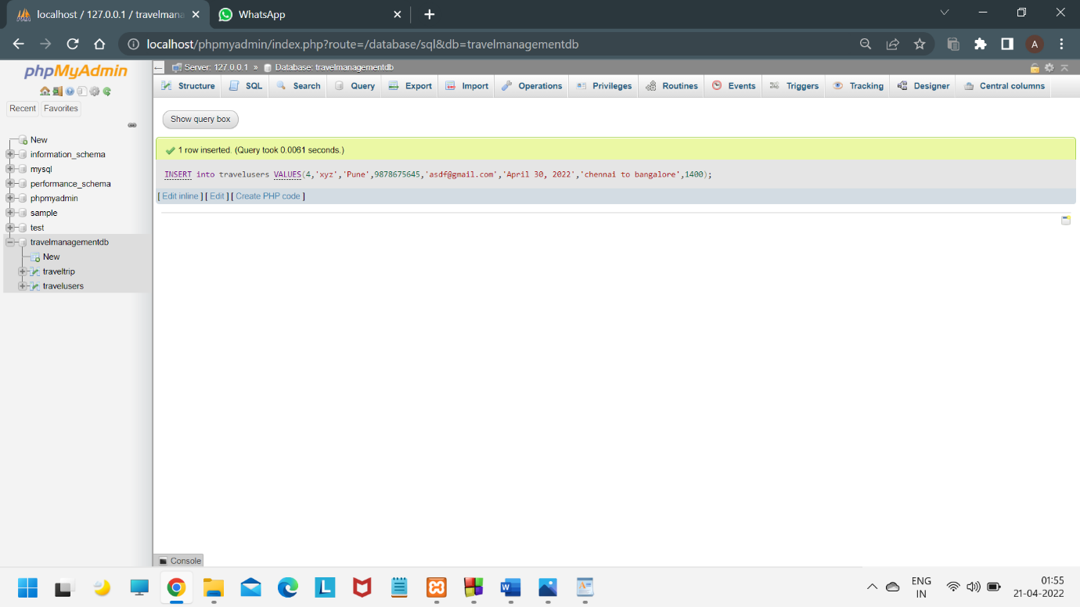

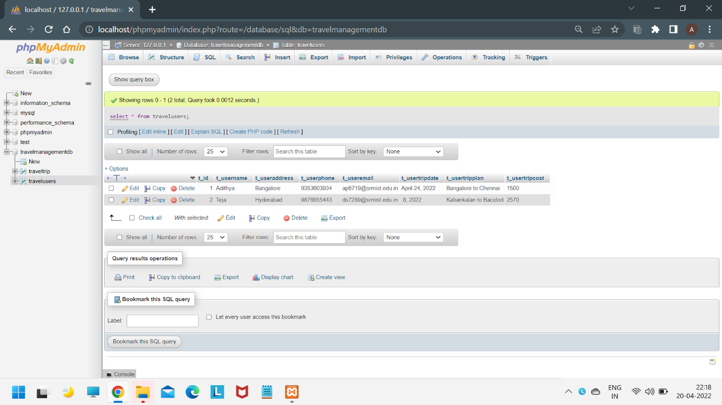

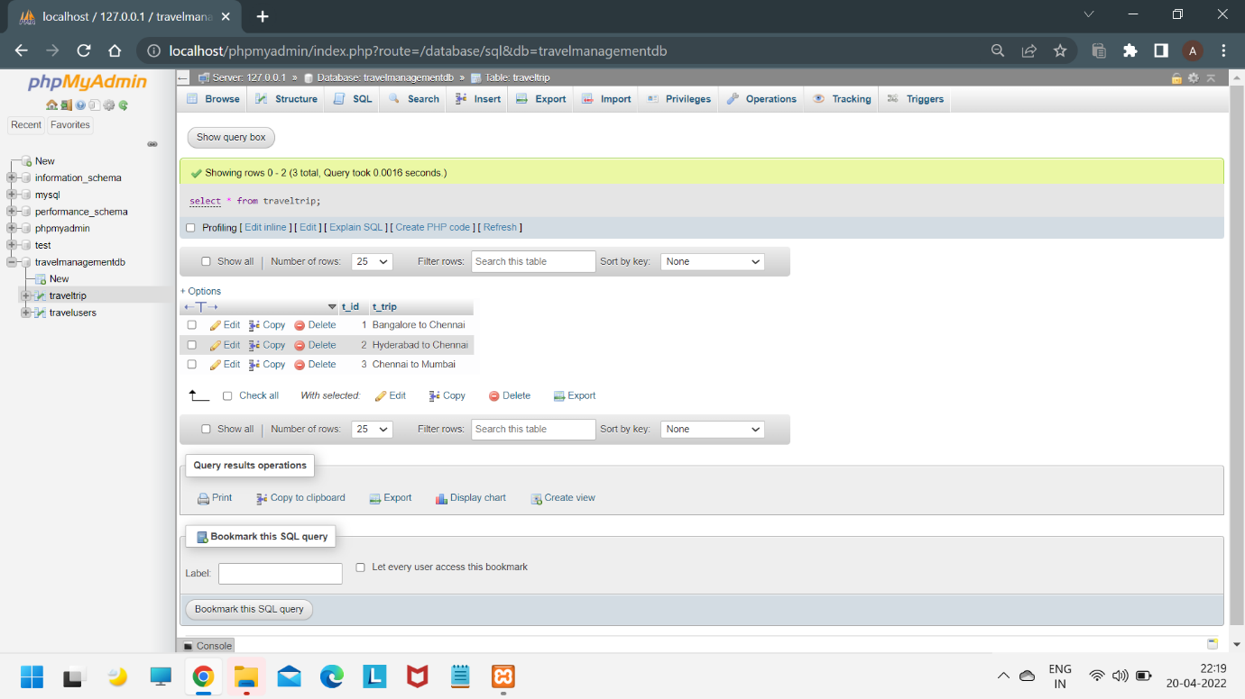

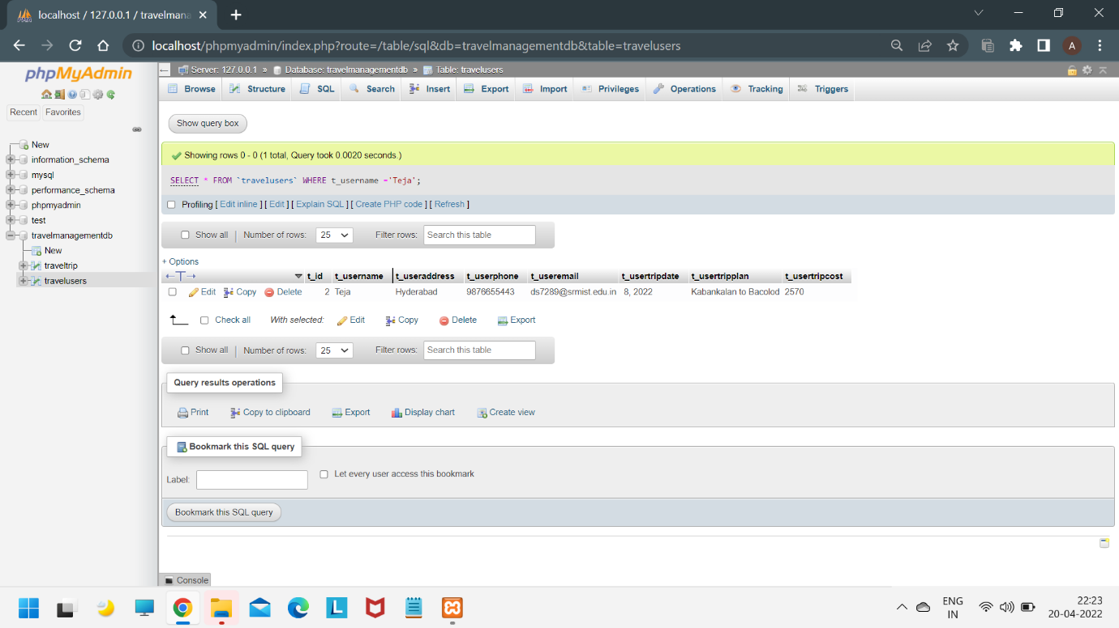

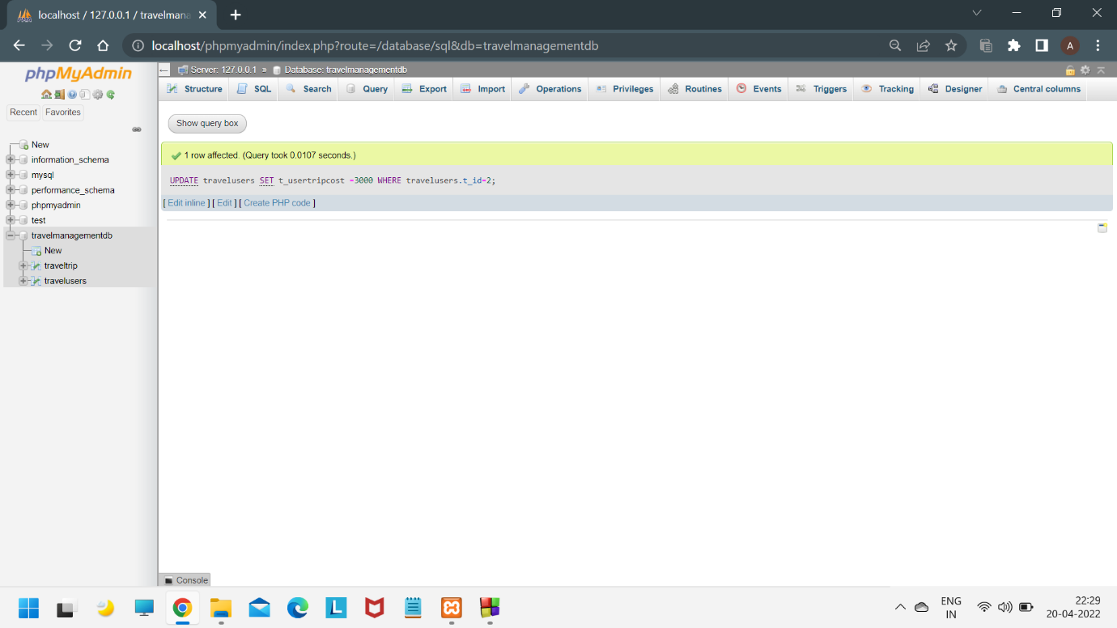

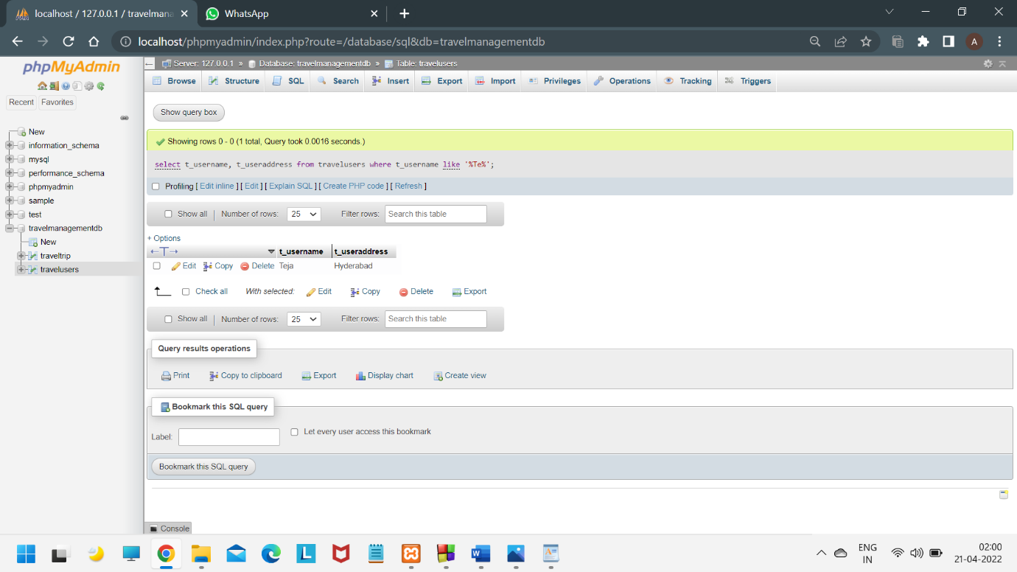

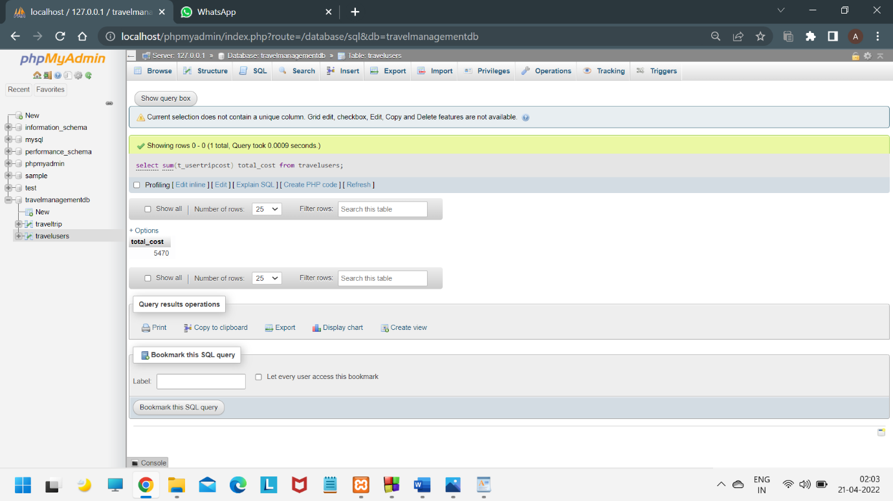

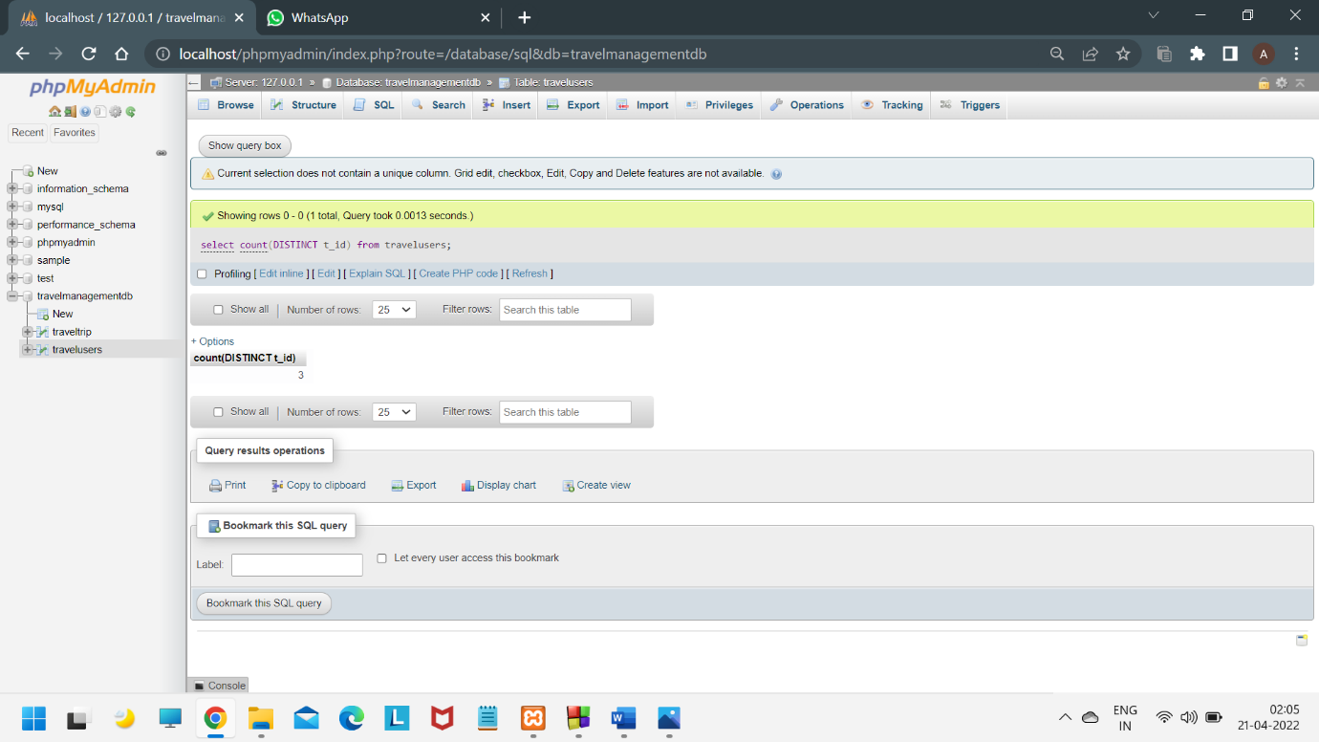

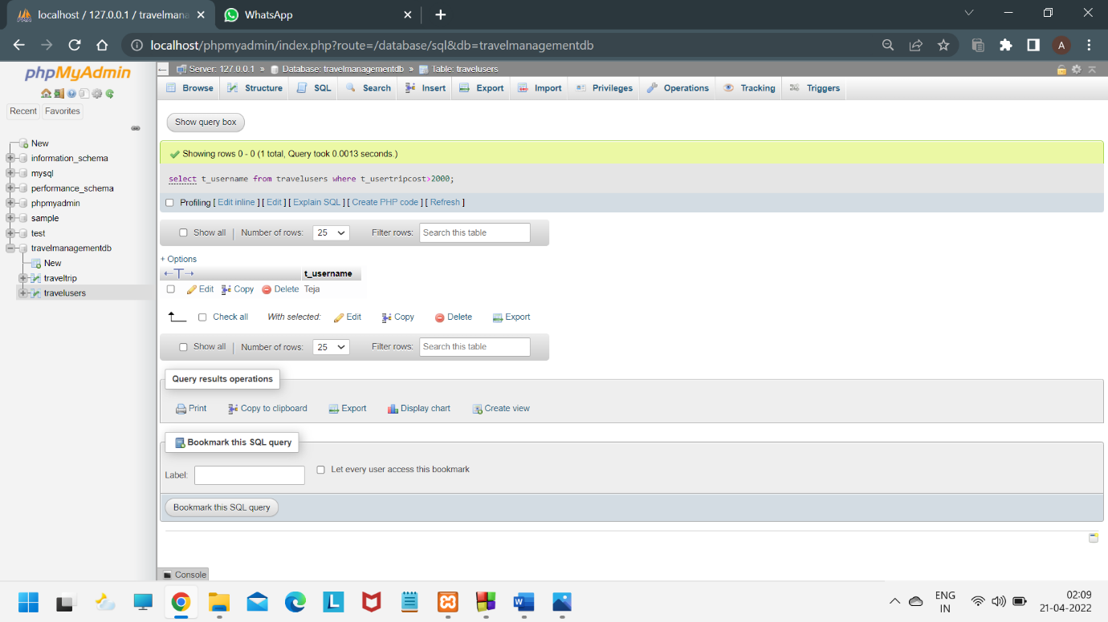

USER INTERFACE (FRONTEND)

C++ COMMAND PROMPT

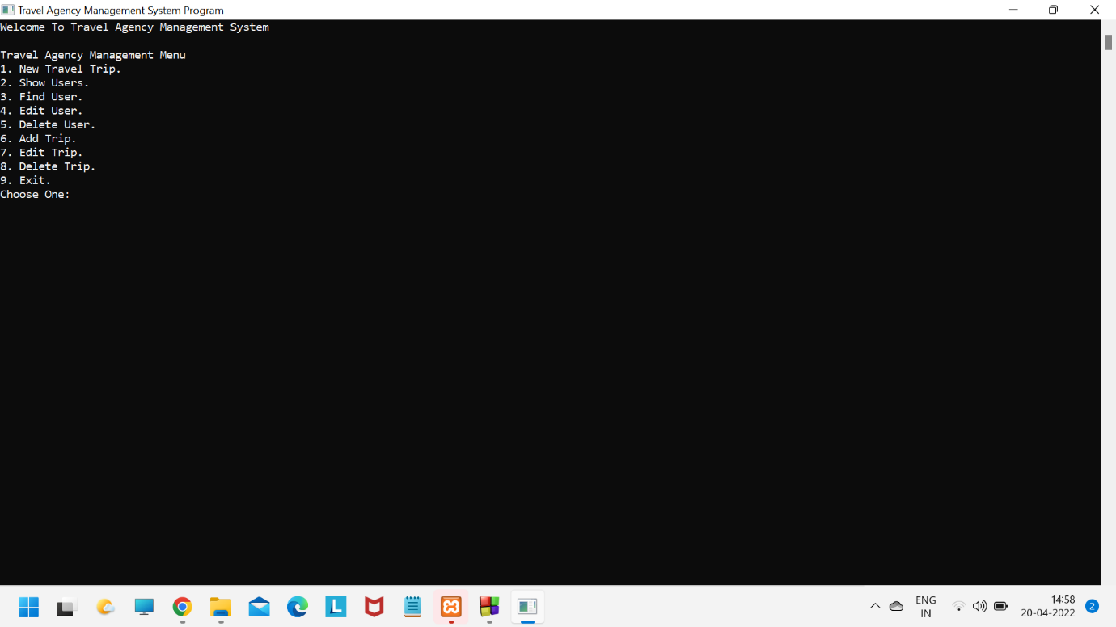

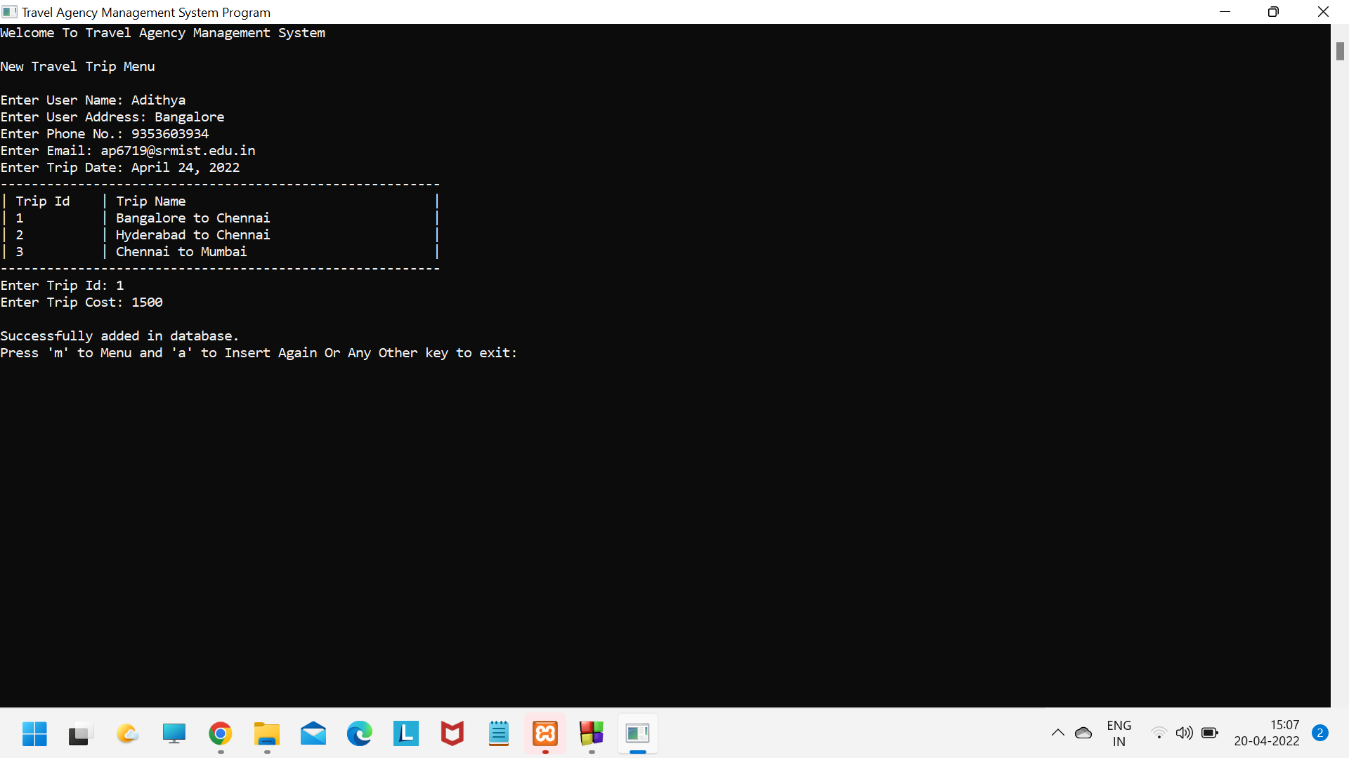

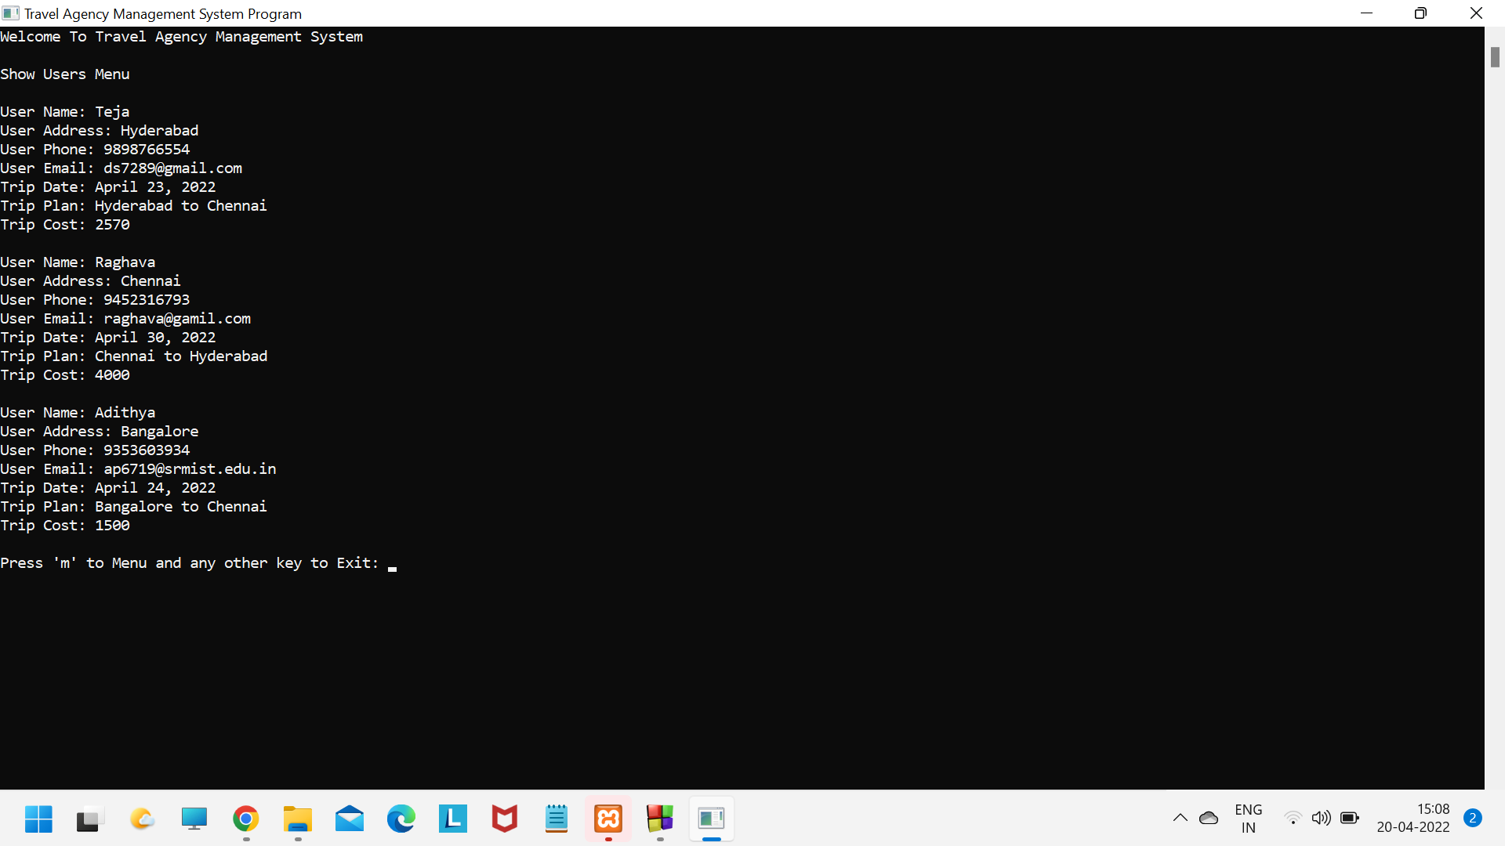

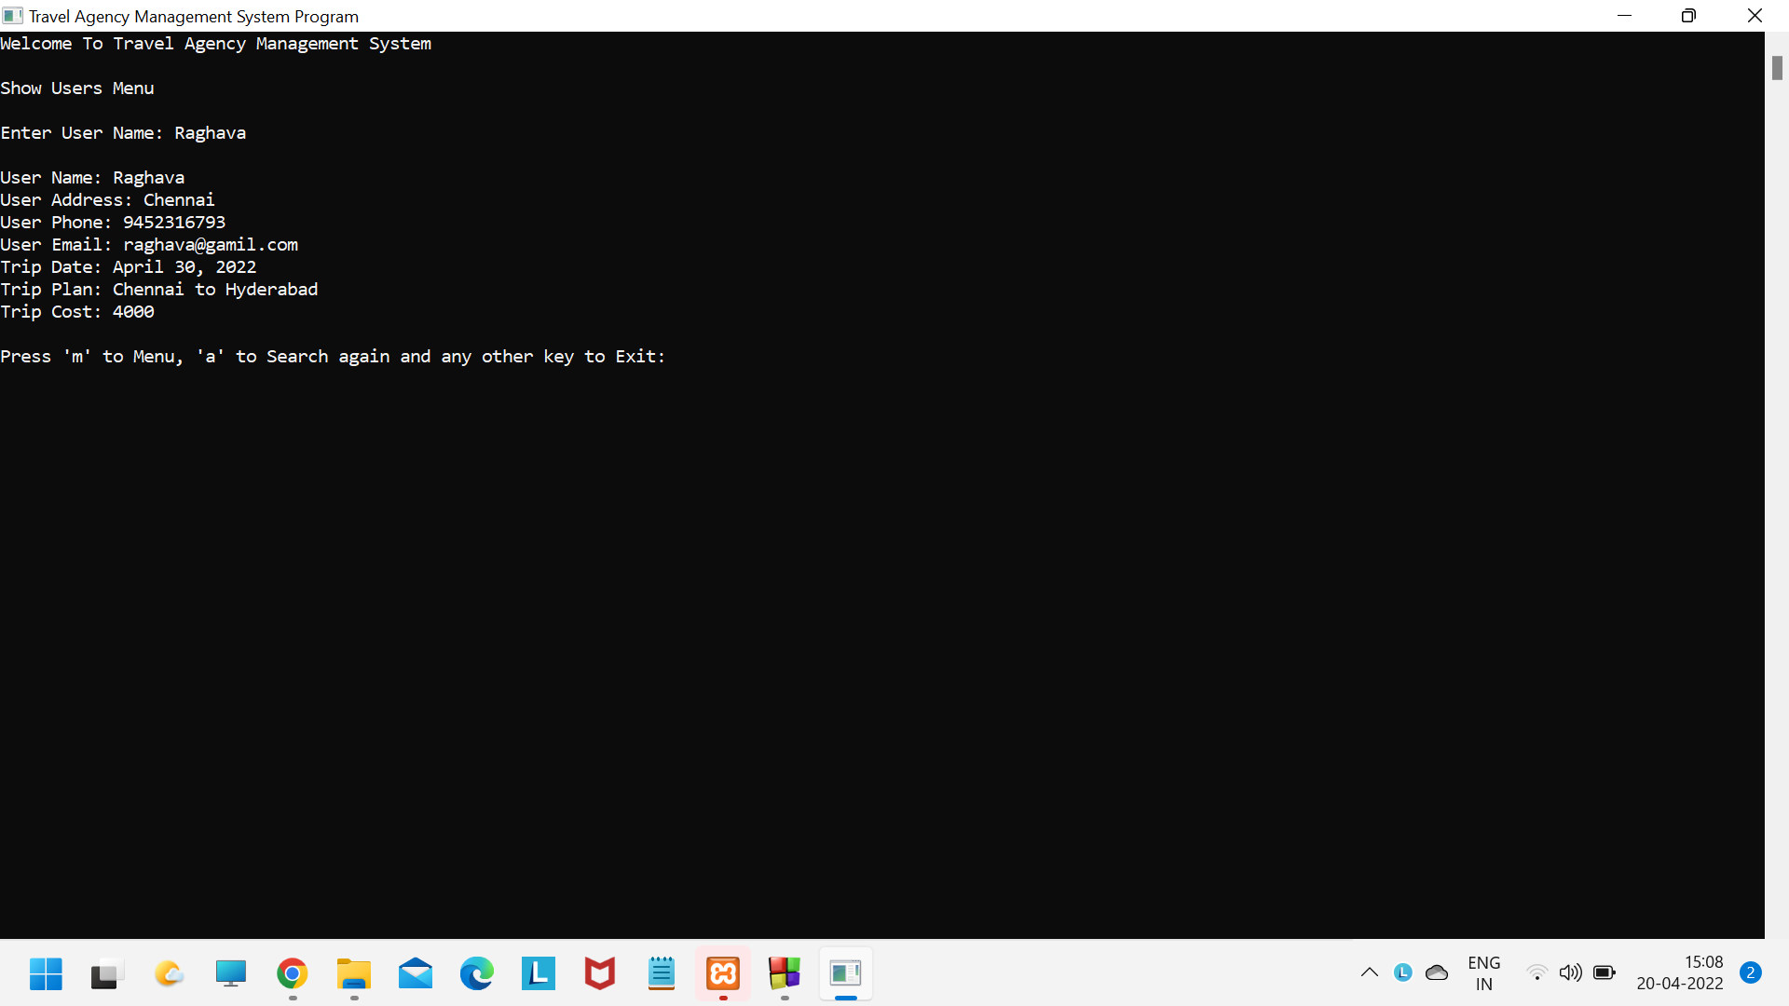

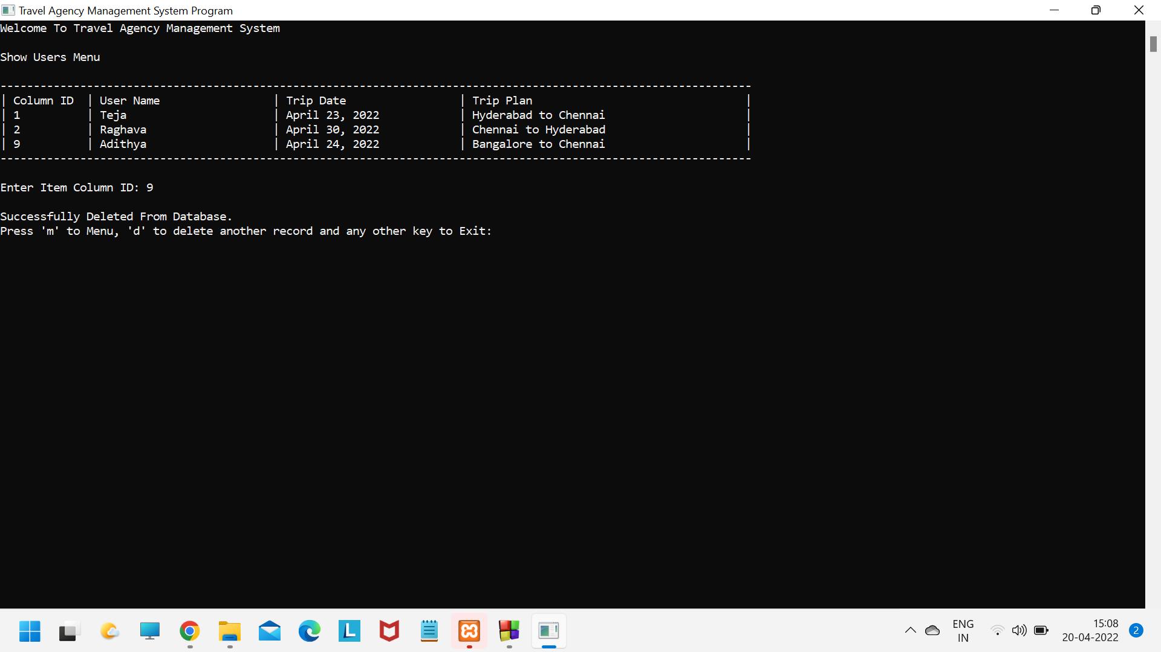

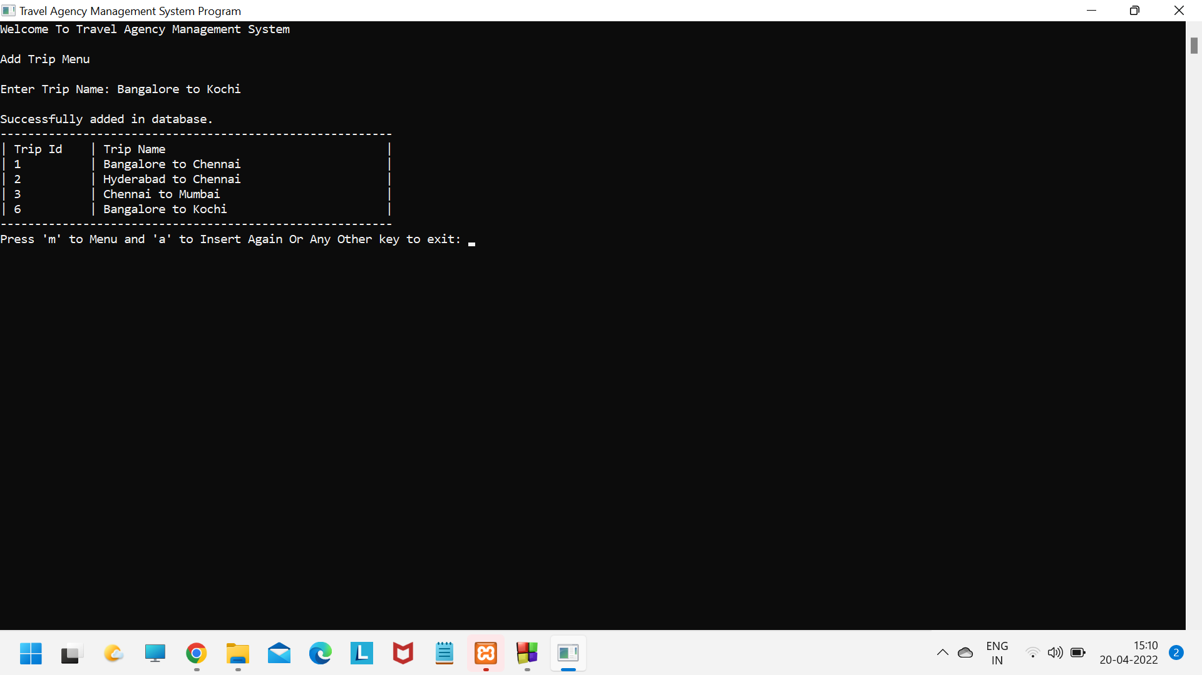

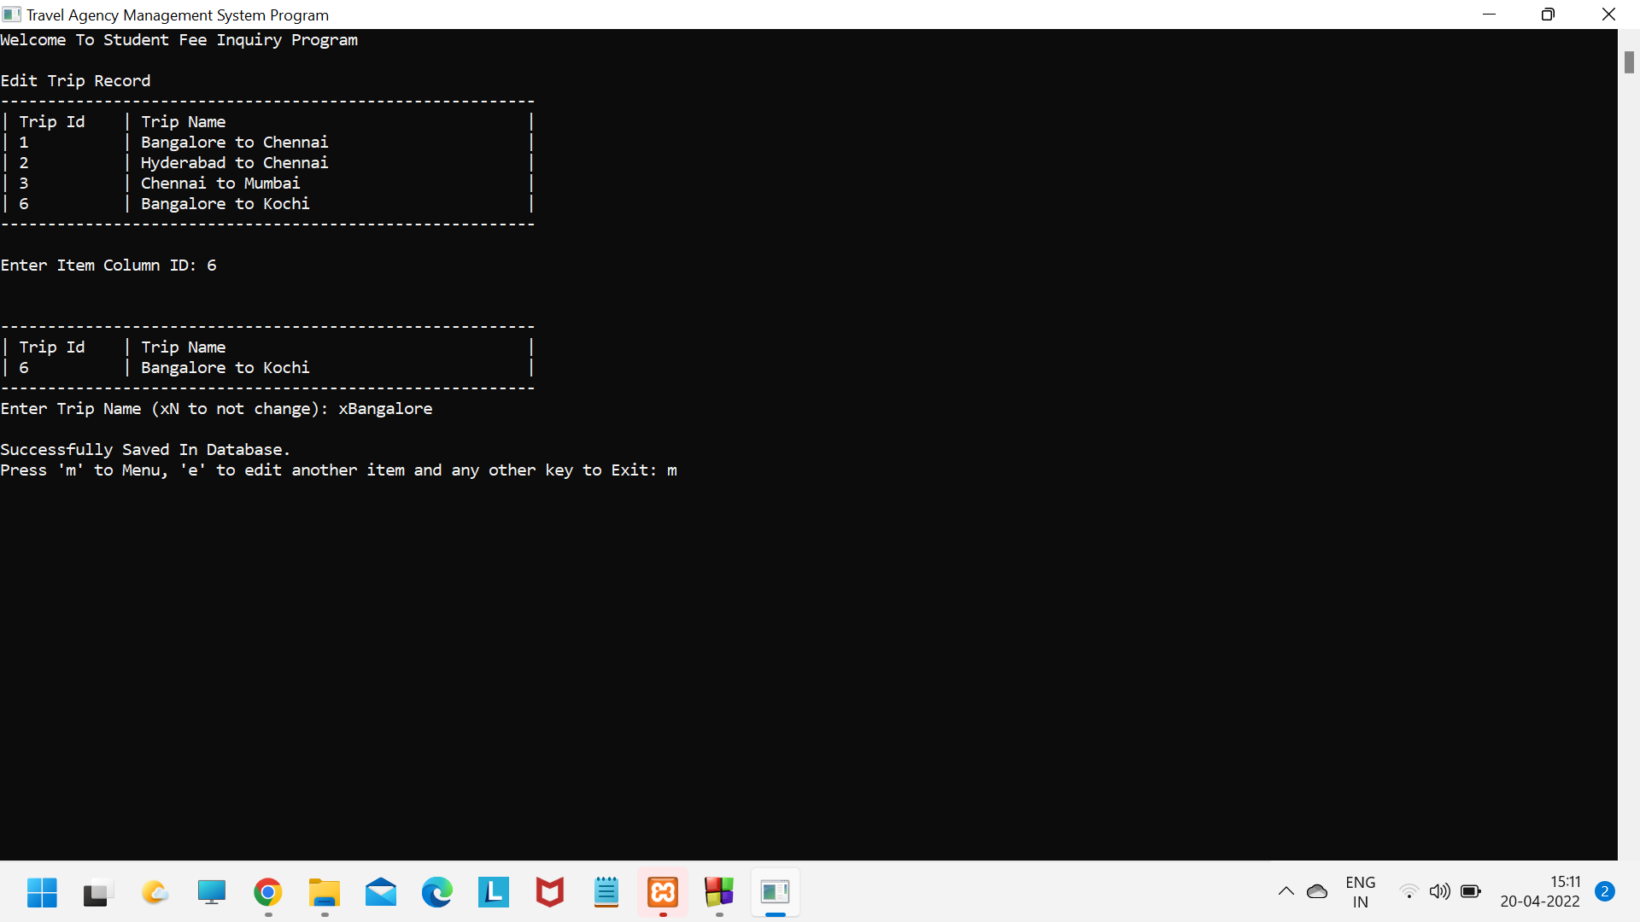

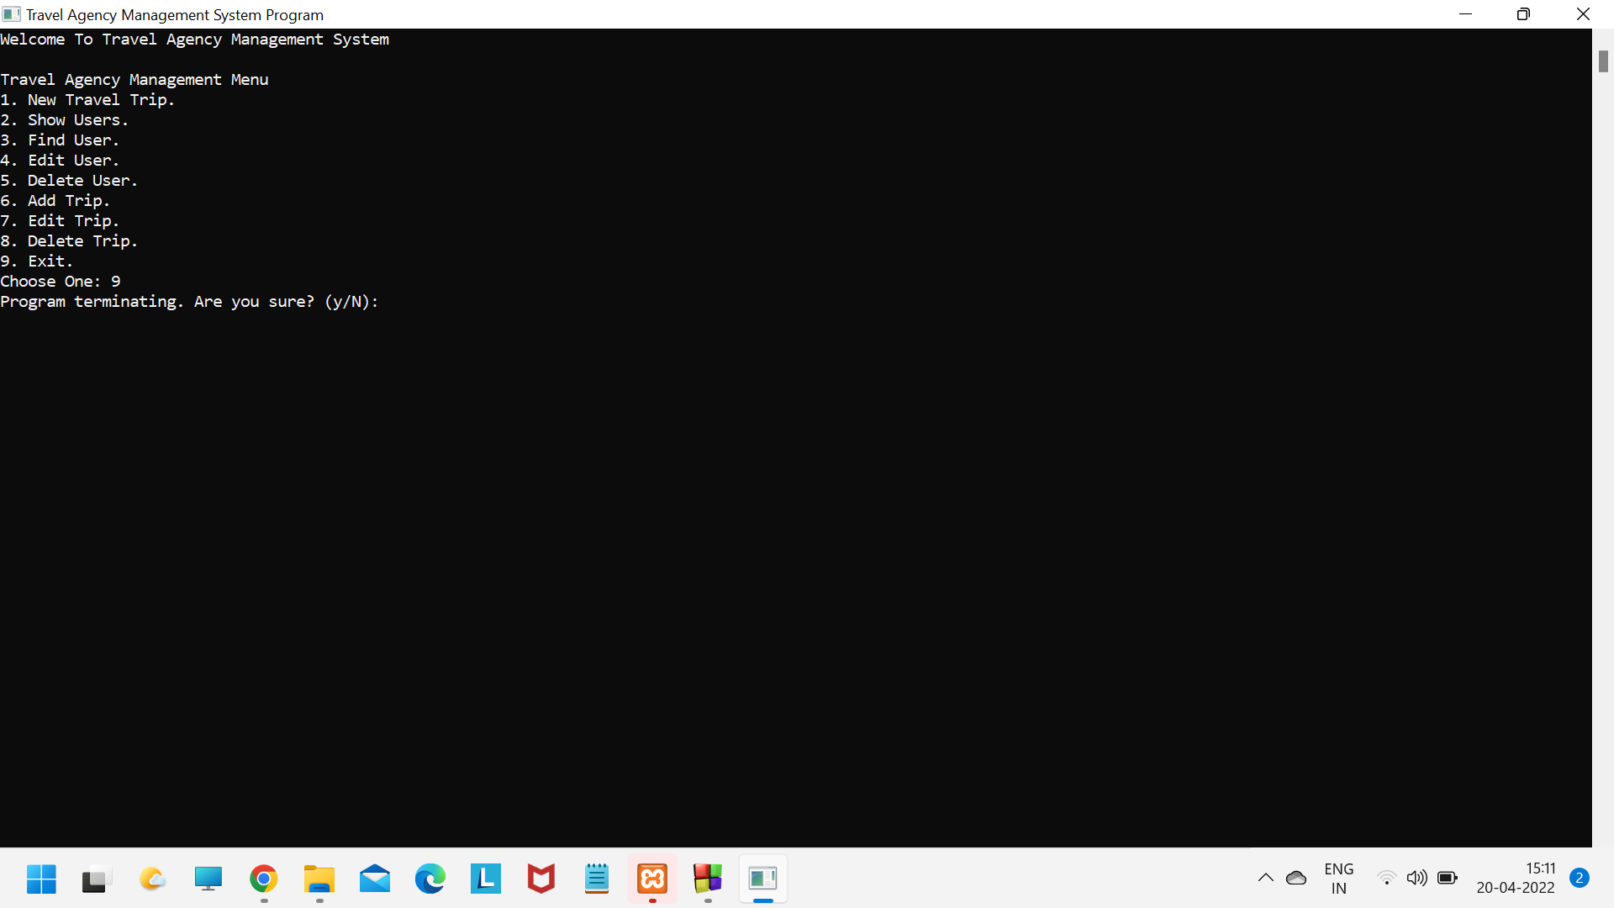

**CONCLUSION AND FUTURE WORK**

The above project derived from the ER diagram successfully manages to store the data in the database and satisfies the functionalities .This project is a simple application which facilitate users to mange their travel data in an organized way.

We had considered the most important requirements regarding the backend and connection of database and we are also working on the frontend of the project for login system which can improve the security of the system and a user friendly experience. These applications are already in progress and in future they can be upgraded and may become part of amazing technology.

**REFERENCES**

* <https://projectworlds.in/free-projects/php-projects/travel-management-system-project-in-php-mysql/>
* W3schools